The tree was built with 3 broad goals in mind:

* Take better advantage of some major part packs, in particular BDB and Nertea’s mods, without being held back by concerns over compatibility with different mod combinations.
* Make tech progression a bit more “rational”, focusing on increased capabilities rather than arbitrary distinctions of size that inconvenience the player without substantially affecting what they can achieve.
* Give an RP-1-like feeling of early progression, advancing gradually from early sounding rockets to first satellites to crewed spaceflight, while still working with the actual gameplay balance rather than getting caught up in historical reenactment.

Every tech other than start is new, so there’s no compatibility for unsupported mods; check the mods spreadsheet for current compatibility and recommendations. As a bit of a fallback option, though, the stock techs are all included as hidden techs with 1 cost to the left of the tree, so in extremis any part not on the main tree should show up there and you can unlock it when it seems appropriate to you (though I think these techs will only appear if they contain parts and not if they just have upgrades).

The tree is arranged somewhat similarly to ETT, radiating out from the center into a number of branches, with mostly independent progression along each one but a fair few interconnections where they make sense and help control progression. Tech science cost follows a curve broadly similar to stock/CTT, though the greater number of starting branches generally means a higher total cost to reach each tier in at least the early game. There are also a number of techs cheaper than their predecessors, representing cases where most of the fundamental research has already been done and it just takes a little more investment to apply it to new cases (e.g. surface labs combining research from surface habitation and orbital labs).

Techs can broadly be divided into 15 main tiers—though plenty of individual techs have intermediate costs—with each tier generally corresponding to a historical period, but with a fair few adjustments for gameplay balance, particularly towards the later tiers where I want to allow for non-historical techs and we start getting into the future (though the last few tiers are basically just FFT techs).

|  |  |  |  |
| --- | --- | --- | --- |
| Tier | Era | Cost | Reference Examples |
| 1 | 1920 | 1 | WW1/interwar aircraft, early rocket experiments |
| 2 | 1950 | 5 | Jets, V2, sounding rockets |
| 3 | 1955 | 20 | X-1, Jupiter, Sputnik |
| 4 | 1960 | 40 | X-15, Atlas, Mercury, Luna |
| 5 | 1965 | 80 | Titan, Gemini, Surveyor, Mariner |
| 6 | 1970 | 150 | Saturn, Apollo, Lunokhod |
| 7 | 1980 | 250 | Shuttle, Skylab, Viking, Voyager |
| 8 | 2000 | 400 | Merlin, NERVA, Skylon, ISS, Cassini, Hubble |
| 9 | 2010 | 600 | Kepler, Dawn |
| 10 | 2020 | 900 | Starship, Orion, Mars mission |
| 11 | 2050 | 2000 | Advanced fission, Fusion, advanced ions, outer planet missions |
| 12 | 2100 | 3000 | NSWR, antimatter, colonies |
| 13 | 2200 | 5000 | Advanced NSWR, intermediate Fusion, cryogenics |
| 14 | 2300 | 8000 | Advanced Fusion |
| 15 | 2500 | 10000 | Beam-core Antimatter |

Here’s a quick run through the logic and recommended mod compatibility for the major branches of the tree:

Atmospheric Engines

A fairly straightforward tree: Powered Flight only costs 1 science and gives both early engines and basic aircraft parts, allowing for a flight-first approach, and in general aircraft tech is cheaper than in stock; Easy progression can be made along a few cheap propellor and helicopter techs built around Airplane Plus’s engines, and then an extra mid-game tech holds tiltrotors and electric propellors. The jet techs are a bit more expensive, but ramjets are still much cheaper than in stock to make midgame SSTOs a bit more viable, and then there’s a vectoring/VTOL branch and a scramjet tech that for now just holds the one Mk2 Expansion engine.

**Airplane Plus** is the main mod recommended to make best use of this branch, but **WaterDrinker**, **SXT**, and **Mk2 Expansion** also work well.

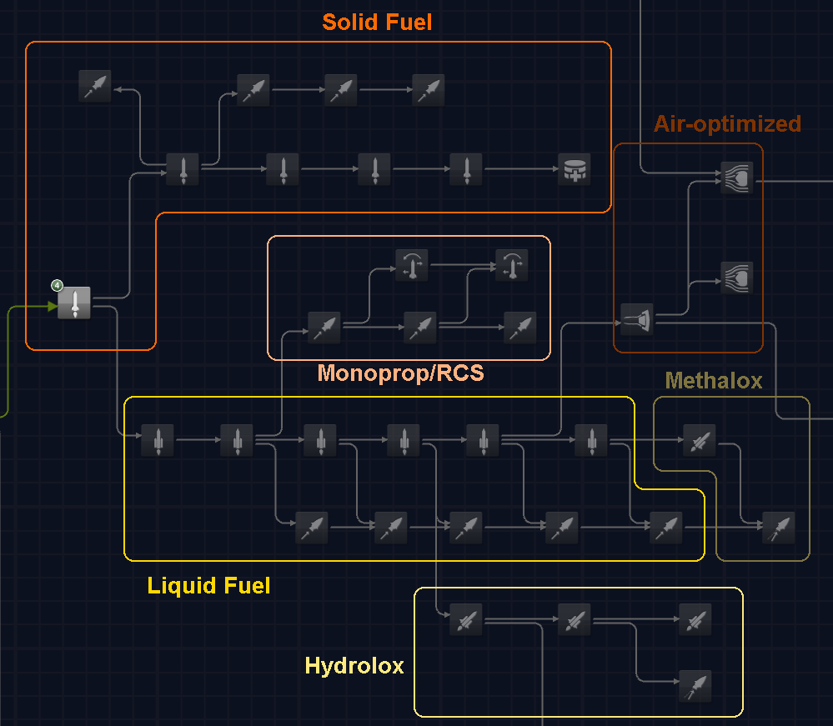

Chemical Rocketry  
  
Split into solid, monoprop, LFO/methalox, and hydrolox branches, all mostly built about BDB. They’re generally split into surface- and vac-optimized lines (except for monoprop), and individual engine placement is mostly based on Isp, with a few adjustments for TWR, and tiny vac engines are also generally placed a bit later.

The solid fuel branch is all fairly cheap, giving you an option for quick progression if you can deal with the control limitations, with one extra mid-game tech covering advanced solid fuel concepts like metal-oxygen rockets from Rational Resources or air-breathing solid rockets from Mk 2 Expansion.

The monoprop branch is just a single vac line, giving slightly quicker access to higher-end vac engines, but at the cost of losing some potential progression towards the upper-end LFO/hydrolox engines; and also branches to the RCS techs.

The LFO line is fairly long to take proper advantage of the BDB engines (and honestly could have been even longer, but I wanted each tech to feel like a tangible upgrade), with the stock reliant and swivel only unlocking at the 5th tech, and the whole line is capped off with a pair of techs for the CryoEngines methalox rockets.

And finally the hydrolox branch is fairly short, to the point that some engines may be effectively outdated by others as soon as they’re unlocked, but I figured if it was too long it might discourage its use compared to nukes and ion engines that start unlocking at about the same time. The hydrolox and methalox branches both reach the same maximum cost of 400 science, but the hydrolox branch is a bit shorter, giving a bit of tradeoff between going for the greater flexibility of LFO/methalox versus aiming to get higher Isp earlier.

Finally, there’s a short offshoot line for aerospikes and then R.A.P.I.E.R. and similar dual/mode engines (also requiring ramjets), with an extra tech for the air-augmented rockets included in a few mods.

The earlier techs are built largely around **BDB** and that’s perhaps the most critical mod for the overall tree to work well; **TantaresLV** also works okay but tends to unlock a bit later than you might expect because of their high Isp; and the later parts of the tree tend to work best with **CryoEngines**.

Power, Thermal, and Ion engines

The entry power storage tech unlocks all battery parts (aside from a couple starting ones), because they all seem to have about the same power density.

At the top, there’s a couple midgame wind power nodes specifically for the MMSEV parts, one for starting conventional windmills and one for vertical wind turbines.

Fuel cells is the cheapest power production tech (20 science), leading then to nuclear power (and a tech for near future’s capacitors), with 2 RTG techs split based on power density and then 2 reactor techs split based on a total output of 1000 Ec/s, with the latter reactor tech unlocking fuel cannisters and so allowing for in-flight reactor refueling, and then a final nuclear processing tech unlocks the NFT fuel reprocessor and FFT smelter. The overall cost curve is intended to be significant investment for early/mid game but still accessible for anyone who wants to commit early to outer planet probes or NTRs.

Solar power is split into an admittedly fairly gamey progression of static panels, deploying panels, and sun-tracking panels, then Solar Wing for deploying panels over ~12 Ec/s and a final tech for large rollout/blanket panels. The entry cost is a bit high for early game but then stays fairly low thereafter.

Conversely, the thermal branch starts cheap to give reasonably easy access to the heat shields tech, but then rapidly increases in cost to access the Heat Control high-temperature and graphene radiators, and a final tech for the Sterling Systems liquid film radiators, making them heavy investments that might be worth it for easier management of the FFT engines.

The ion/electric engines branch is also placed here for convenience, though it’s also locked behind more expensive science techs; it’s generally built around NFP engines with some allowance for other mods such as Supplementary Electric Engines; the first tech unlocks the NFP pulsed plasma rcs thruster, as well as any resistojets from other mods; the second tech unlocks basic ion engines and arcjets, and then later techs unlock higher-efficiency ion engines; this then branches off to a line for the NFP magnetoplasmadynamic and pulsed inductive thrusters. The cumulative cost is generally quite high compared to other midgame engine branches, though notably a bit lower than in CTT as somewhat a concession to these being somewhat unattractive engines gameplay-wise.

As you might expect, this whole tree works best with **Near Future Technologies**, though it’s not critical for the early progression; I also recommend picking up **Supplementary Electric Engines** for the early ion techs and the **Sterling Systems** liquid film radiators if you want a good endgame radiator option to go with FFT, though the rest of the Sterling submods aren’t all that well supported. **RLA Reborn** also adds a couple decent early electric engines.

Nuclear and Antimatter Engines:

Lategame engine techs broadly follow 3 branches that branch of the nuclear reactor line but then stay independent, giving a bit of a potential tradeoff: fission offers the best early rewards and generally higher TWR, but terminates the soonest in terms of maximum Isp; antimatter requires a very high entry cost with fewer early benefits but ultimately leads to the most powerful engine in the game; and fusion is a bit of a compromise between the two.

The entry-level NTR tech comes at 400 science, intended to be high but achievable for the earlyish midgame, and then 3 more techs roughly cover the range of increasing Isp and thrust for both BDB and Kerbal Atomics engines, and then a couple branching techs cover combinations with jet techs for air-breathing and aerospike NTRs.

The other techs are then pretty much all built around FFT. Nuclear Pulse Propulsion branches off from the middle solid-core NTR tech with a cost of 1,000 science, a bit of a compromise between wanting it theoretically available as early as the midgame for alt-history fun but not wanting such a powerful engine to obviate the importance of NTRs and Ion engines; the enormous unlock cost in funds should help provide a bit of an extra barrier. This then leads into a couple more lategame techs covering various other FFT fission engines (NSWR, fission fragment, and pulsed fission).

Nuclear fusion branches off from the reactor tree, with overall costs generally balanced against the advanced fission line to try and ensure neither is obviously superior, with fusion generally offering higher efficiency but lower TWR at each tier.

And then finally antimatter branches off from the plasma propulsion line and nuclear reactor lines because I didn’t really have a better place to put it, wanted it to have a high cumulative entry cost, and didn’t want it to close to the fission or fusion lines. Note that though the antimatter-catalyzed fission and fusion drives unlock here, they need fuel tanks unlocked by the entry-level techs from the other lines.

There is also one final 15,000 science FTL tech that’s empty for the moment, but I’m sure I’ll add some warp drive mod eventually.

**Far Future Technologies** is, of course, the recommended mod for most of this section of the tree; The **Sterling Systems** engines and reactors are in there but don’t fill out the tree too well, and eventually I’ll probably add some **Interstellar** support but I’m not going to adjust the tree structure for it (though I can maybe add some side techs for stuff like solar sails at least). For the NTR branch, you could just get away with stock and **BDB**, but **Kerbal Atomics** and **Near Future Aeronautics** work best for the later techs.

Structural, Fuel, and Docking

The airframes branch along the top covers most aircraft parts and is all quite cheap, with Supersonic Airframes (for Mk 2 parts) and Heavy Airframes (for Mk3 and similar large mod aircraft) each costing just 40 science; in principle you might use this as cheap access to large tanks (though I’ve put some of the bigger LFO parts in the fuel tanks line instead), but I guess don’t do that if you want the intended progression. There’s also an extra tech for airbrakes, grid fins, and similar advanced aerodynamics parts, and a Huge Airframes tech essentially just for the Mk IV mod, but maybe I’ll add OPT eventually as well.

The structural branch is split into a construction line for adapters, decouplers, fairings, engine plates, etc., and a fuel tank line, both split based on size into <0.625, 0.625-1.5, 1.875-3, 3-4.5, and >4.5 m tiers, though with the quirk that the second size tier comes first and is split up a bit differently such that you can get some basic fuel tanks and parts for staging before unlocking fairings and >0.625 m decouplers. Each tier unlocks all parts for that diameter, because it’s a bit of an arbitrary inconvenience to require you to stack shorter tanks rather than have access to longer ones, save that the smallest 0.625 m tanks unlock with the Specialized Tanks tech, as that’s more of a substantial barrier to building small upper stages and probes. The whole tree is fairly cheap, topping out at 250 science for the largest tanks, the idea being that it should take some investment to build gigantic rockets but it should never be a serious barrier, and the alternate unlocking of construction and tank techs also allows for Saturn-IB-like kludges of sticking tanks together to cheat your way to larger sizes before unlocking the proper tanks.

Branching off from the structural tree is a somewhat expensive tech for fuel pumps; a couple techs for robotics and then grapplers; and then the docking ports line, starting with some small gendered docking ports from BDB; then unlocking androgynous ports up to 1.875 m; then a final tech for larger docking ports.

Parachutes get their own independent 2-tech line, because I wanted them available very early on and they don’t really tie into anything else (I could have them lead into inflatable habs, but it’d be annoying to get the arrow through neatly and it’s a bit pointless given the relative cost); one entry tech for main chutes and then a second tech for drogue and radial chutes. Maybe at some point I’ll add balloon mods and branch them off of here.

This overall branch should work basically fine with any mod combination, though for the starting docking ports you need either **BDB** or **Tantares**.

Command, Habitation, and Surface

The avionics line is fairly straightforward, with one entry-level tech (branching from basic science) for basic probe cores with no SAS modes, one for stability assist, and then one for everything else, because I don’t think the extra SAS modes past prograde/retrograde are really worth any extra investment; and then 2 extra techs unlock cores with remote guidance and non-command reaction wheel parts.

The first crew capsule tech unlocks at 40 science—87 cumulatively with all prerequisites, and more realistically probably around 150ish to get all the other necessary components. That hopefully ensures there’s a substantial pre-crew early game without making it too hard a goal to reach fairly quickly if you want to. You can in principle just use the cockpits from Powered Flight to do crewed spaceflight early, but I guess don’t do that. There are then 3 more capsule tiers for 2-crew Gemini-like capsules, 3+ crew capsules, and a final tech for various mod capsule with very high crew density or other nice features.

The habitation branch is a bit of a tangled mess to cover various habitation functionalities, and may not work well across different life support mods; at this point I’ve only balanced it for USI-LS, mostly with SPX and BDB parts. Habitation spaces are generally spaced out based on crew capacity and habitation time, first unlocking 1- or 2- crew modules as well as orbital command pods for early landers; then larger hab spaces as well as supply containers; and then branching out into the top line for ever greater habitation times and multipliers; the middle two techs for structural habitation concerns, unlocking first parts for modular station construction; and then the bottom science/life support line, unlocking first labs, then recyclers (most dedicated life support recyclers should be locked here, but some do get accessed earlier in labs and advanced capsules), then agriculture parts of increasing scale. The Huge Station Components tech is a bit of kludge to lock some large BDB and SPX parts behind both habitation and life support research, and then there’s a final endgame Colonization tech for the Civilian Population mod. The overall cost curve is meant to make habitation and life support a significant concern in the midgame but still not make it too hard to get what you need for interplanetary vessels and generally unlock everything before the lategame, with the funds cost to launch and supply stations and vessels probably being the greater concern.

The surface exploration line first unlocks basic landing legs and rover wheels, and then the later 2 techs serve as a bit of a catchall for various surface-related parts, including rover parts, larger wheels and landing legs, and BDB’s Icarus mun hopper, though I split off any boat parts into a separate tech, and there’s also a couple techs for habs and labs intended specifically for surface use; there’s also a preliminary EVA tech which basically just serves as a place to put inventory parts, the jetpack probably being the most significant.

Finally, there’s a couple mid-lategame techs for early parts production like in OSE Workshop and full extraplanetary vessel construction, though I haven’t used these sorts of mods much so I’m not certain how well they’re balanced.

The capsule line naturally works best with **BDB**, though **Tantares**, **M.O.L.E.**, or **Making History** could also work with it; the habitation techs are built around **BDB** and **Station Parts Expansion Redux**; the life support/agriculture line is for now just built to support **USI-LS**; **Buffalo2**, **Feline Utility**, and the **Malemute** rovers are all supported for heavy vehicles.

Science and Comms

Comms parts follow a fairly straightforward progression along tiers of 1 M, 100 M, 5 G, 20 G, 200 G, and unlimited max power, though a couple very light 16 M antenna in BDB are placed a tech later so they don’t immediately obsolete heavier parts. Direct comms and relays are split to encourage sending early probes before being able to undertake more complex multi-vessel missions, following the same progression save that no relays unlock at the first tier and the final tier is just relays because I haven’t seen many mods with direct antennae for over 200 G.

The science tree is based mostly around BDB and DMagic, and is generally a compromise between a sensible arrangement that somewhat follows historical progression while still working with the gameplay balance (though I did add a patch to bring the stock magnetometer’s science return down to be in line with mod magnetometers, because it seemed silly to push it out to some later tech, and also reduce the science return of the USI sounding rockets to work better as starter science instruments). It’s hard to say how well balanced it is, I’ve mostly kept the costs fairly low to ensure that you’re not unlocking parts for more than the science you ultimately get out of them, and generally the idea is you should be more restricted by your ability to send out more missions to different bodies rather than availability of instruments to send on those missions. Generally the most expensive tree is imagery along the bottom, which is intended to work well with BDB’s intended film recovery gameplay, requiring you to recover the earliest film parts and then progressively unlocking parts that can transmit a larger portion of their data.

The end of the tree leads into resource surveying and ISRU, which are mostly kept on separate branches to help encourage diverse research and generally intended to become available around the midgame, and there’s a couple extra lategame techs for special NFT/FFT ISRU parts. I considered having more connections between the science tree and other branches, but it would’ve ended up looking very tangled and I think I prefer letting the progression be a little more flexible; as it is, the communications branch gets a short radio astronomy line, electromagnetic research leads into ion engines so that it requires a bit more leadup than just the basic power tech, and materials studies leads into labs because that should be tied into the science tree somehow, as well as a lategame cryogenics tech for DeepFreeze which doesn’t quite fit in anywhere else.

This whole tree is mostly built around **BDB**, but **DMagic**, **Coatl Aerospace Probes Plus**, **Tantares SP**,and **ScanSat** all integrate well with it.